Copyright reserved

Please turn over

**NATIONAL CERTIFICATE**

**INDUSTRIAL INSTRUMENTS N5**

**July 2021**

**23**

**This marking guideline consists of 7 pages.**



**MARKING GUIDELINE**

-2-

**SECTION A**

# QUESTION 1

1.1 True

1.2 True

1.3 False

1.4 True

1.5 True

1.6 False

1.7 True

(7 × 1)  **[7]**

# QUESTION 2

2.1 Pitot tube (1)

2.1.1 A – Impact (high pressure connection)

1. – Static (low pressure connection)
2. – Packing nut
3. – Cooperation cock
4. – Staffing body
5. – Impact opening
6. – Static opening (7)

2.1.2 When the velocity of a fluid starts diminishing✓ due to the presence of the body✓ until it is reduced to zero directly in front of the body.✓ (3)

2.2 • Primary elements

• Secondary elements (2)

2.3 Q = V1A1 = V2A2✓

𝜋𝜋𝜋𝜋2 𝜋𝜋𝜋𝜋2

2,21( )✓= V2()✓

4 4

𝜋𝜋(0,09)2 𝜋𝜋(0,06)2

1. 21( )✓ = V2()✓

4 4

0.0141 =2,827 × 10-3V2 ✓

V2 = 4,988m/s✓ (7)

-3-

* 1. 2.4.1 Advantages
     + - Low costs
       - It can be constructed on location where being used
       - It is not easily damaged (3)

Disadvantages

* + - * Can only be used in open-channel measurement
      * Field calibration is required • Poor accuracy (Any 2 × 1) (2)

2.4.2 • Rectangular weirs

* + - * V-notch weirs
      * Cippoleti/trapezoidal weirs
      * Parabolic weir
      * Suppressed weir (Any 3 × 1) (3)

**[28]**

**TOTAL SECTION A:**  **35**

**SECTION B**

# QUESTION 3

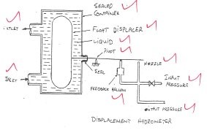3.1

(5)

3.2 • The sliding-plate viscometer utilizes the classical concept of viscosity and uses an electronic micrometer to measure the velocity gradient.

* Since the velocity gradient may be accurately determined, this sensor is equally applicable to materials having Newtonian and non-Newtonian flow properties.
* The viscometer consists of two polished glass or stainless steel plates between which a thin layer of sample is placed.
* Care should be taken to obtain uniform thickness of the sample film, which should also be void of any air bubbles.
* The pulling force is applied through a simple balance beam pivoted on bearings and on a polished steel knife edge.
* An electronic circuit is used to follow the movement of the plate by controlling a servo motor.
* This drives a insulated micrometer and causes it to maintain high resistance

contact with a flag attached to the movable plate. (7)

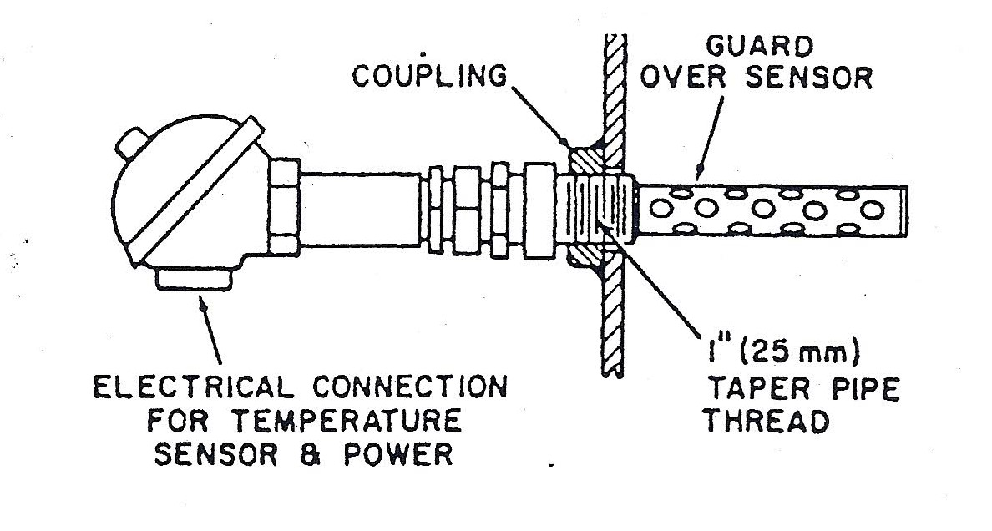3.3

(1 mark for each label)

• The sensing element consists of a thin-walled, hollow-metal socket wrapped over the tape filled with salt crystals.

* Two wires are wrapped over the tape and connected to a regulated, alternating current voltage source; the electric circuit between the wires is completed by the salt crystals.
* When the sensing element is exposed to the sample atmosphere, water condensing on the crystals forms an ionic solution which allows an electric current to flow between the wires.
* This current in turn heats the solution and raises its vapour pressure.
* As more water condenses, more current flows, resulting in a further increase of the solution vapour pressure until equilibrium is reached.
* On decreasing moisture content of the measured gas, water evaporates from the element, decreasing the current flow and resulting in a new equilibrium at a lower solution vapour pressure. • A temperature sensor inside the hollow socket is used to detect sensor temperature and to provide a signal for readout.
* The output calibration can be in terms of dew-point temperature, water

vapour pressure or specific humidity. (12)

**[24]**

**TOTAL SECTION B:**  **24 SECTION C**

# QUESTION 4

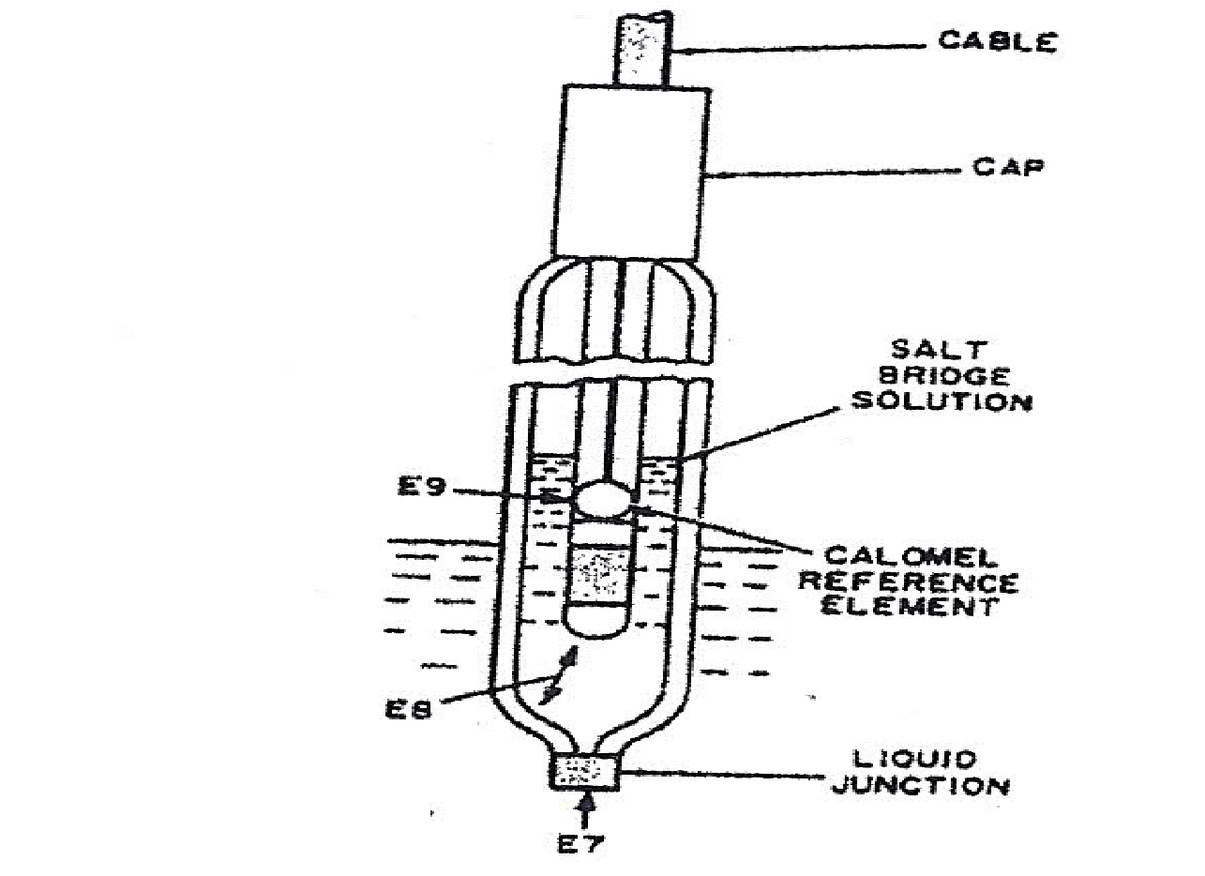4.1

(6)

4.2 A flow of low pressure assembly may consists of a sealed housing✓in which the electrodes are mounted, with their lower ends into a flow-through body with

a bowl,✓ sometimes made of glass, mounted on the underside.✓ (3)

4.3 A – Current adjuster

1. – Current source (AC)
2. – Potentiometer
3. – Current meter
4. – Electrolyte
5. – Measuring electrodes
6. – Current electrodes (7)

**[16]**

**TOTAL SECTION C:**  **16 SECTION D**

# QUESTION 5

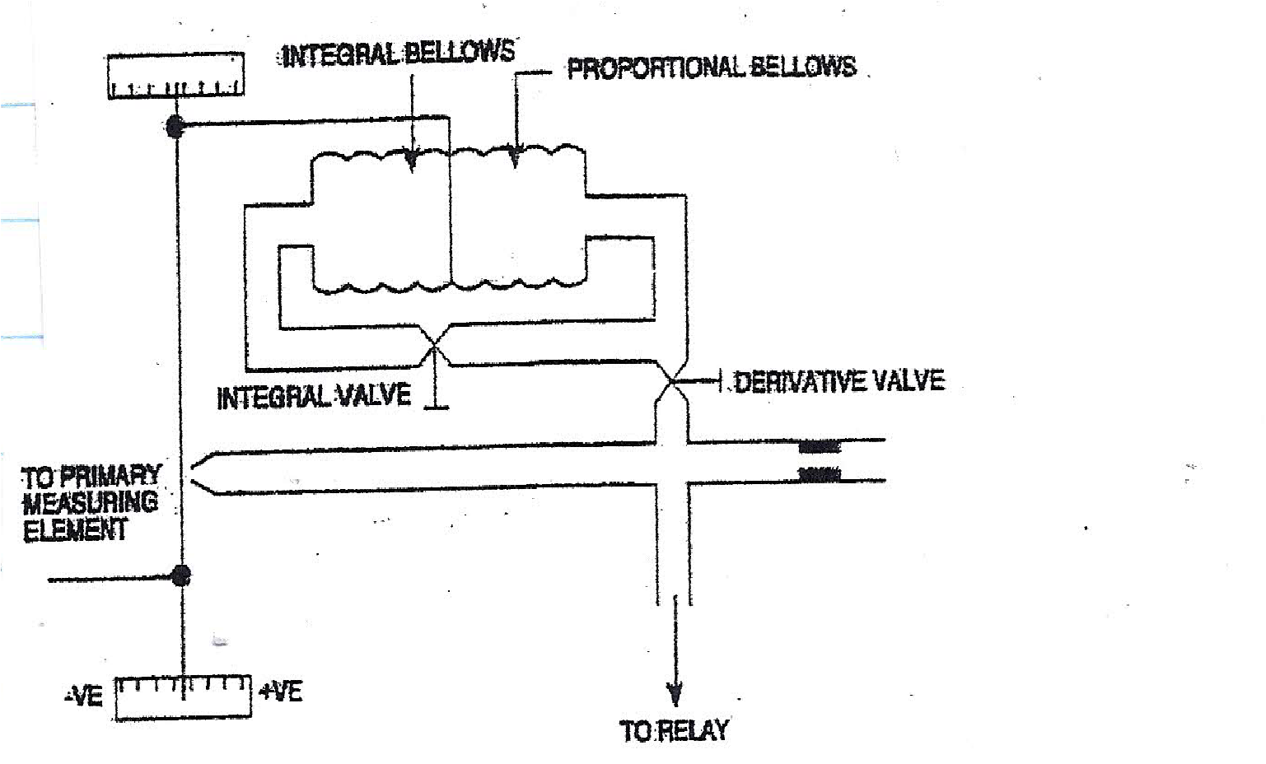5.1

(4 marks for the diagram)

As the measured value begins to increase, it causes the flapper to move towards the nozzle.✓ This will increase the nozzle back pressure,✓ resulting in a sharp rise in output pressure. The increasing pressure in the proportional bellows will expand the proportional bellows and re-position the flapper,✓ thus limiting the output pressure to a value which is proportional to the deviation✓ (proportional action). With the integral valve partly open,✓ air will flow through to the integral bellow at the rate which depends upon the pressure drop across the valve and the size of the valve.✓ Air flowing into the integral bellow will expand the bellow and tends to move the flapper towards the nozzle, increasing

the output pressure (integral action).✓ (10)

5.2 A cascade control-loop system consists of two controllers. The setpoint to the control loop is fed into the primary controller while the output of the primary controller becomes the setpoint to the secondary controller.

input

Process

plant A

Process

plant B

Feedback

signal

output

Manual

setpoint

Feedback

signal

Controller B

Controller A

(10)

5.3 • Proportional control

* Proportional and integral control
* Proportional and derivative control
* Proportional, integral and derivative control
* On-off control (5)

**[25]**

# TOTAL SECTION D: 25 GRAND TOTAL: 100